**DAY:1 PYTHON BASICS + COLAB SETUP**

**Step 1: Open Google Colab**

* Go to https://colab.research.google.com

**Step 2: Create a New Notebook**

* Click on **"File" → "New notebook"**
* A new notebook will open in a new tab.

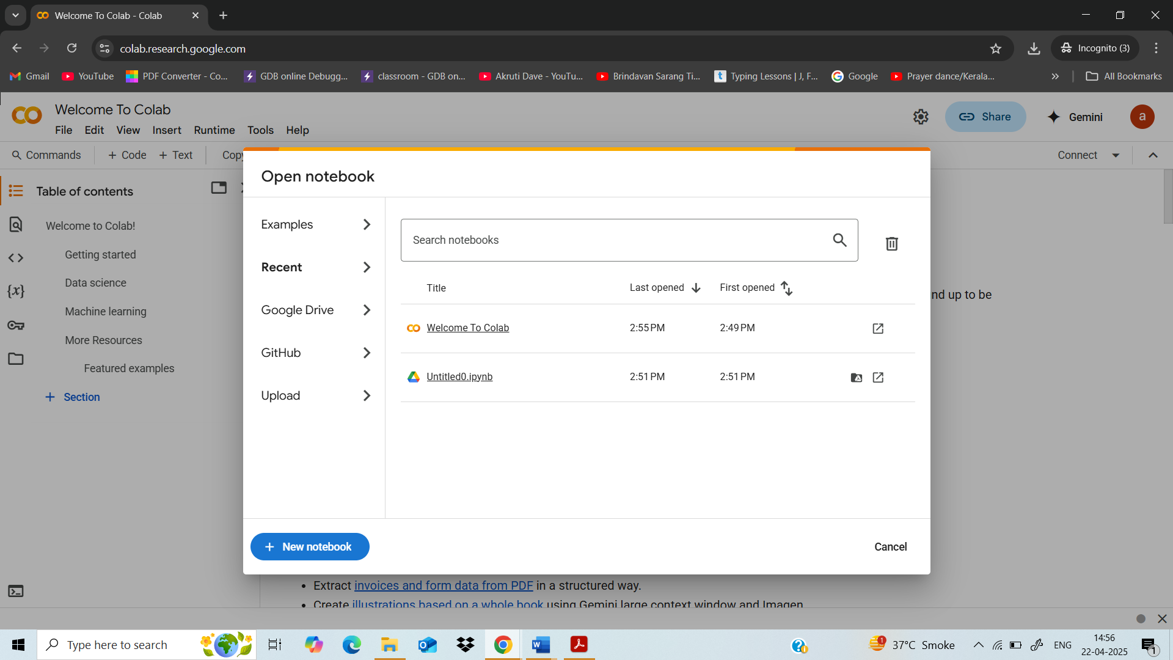

**Step 3: Rename Your Notebook**

* Click the notebook title at the top left (e.g., Untitled0.ipynb) and rename it to Number Guessing Game

**Step 4: Start Writing Your Python Code**

* Click in the code cell and begin typing your Python code for the game.

import random

# Step 1: Generate a random number between 1 and 10

secret_number = random.randint(1, 10)

# Step 2: Ask user for a guess

guess = int(input("Guess a number between 1 and 10: "))

# Step 3: Check the guess

if guess == secret_number:

print("Congratulations! You guessed it right.")

elif guess < secret_number:

print("Too low! The number was", secret_number)

else:

print("Too high! The number was", secret_number)

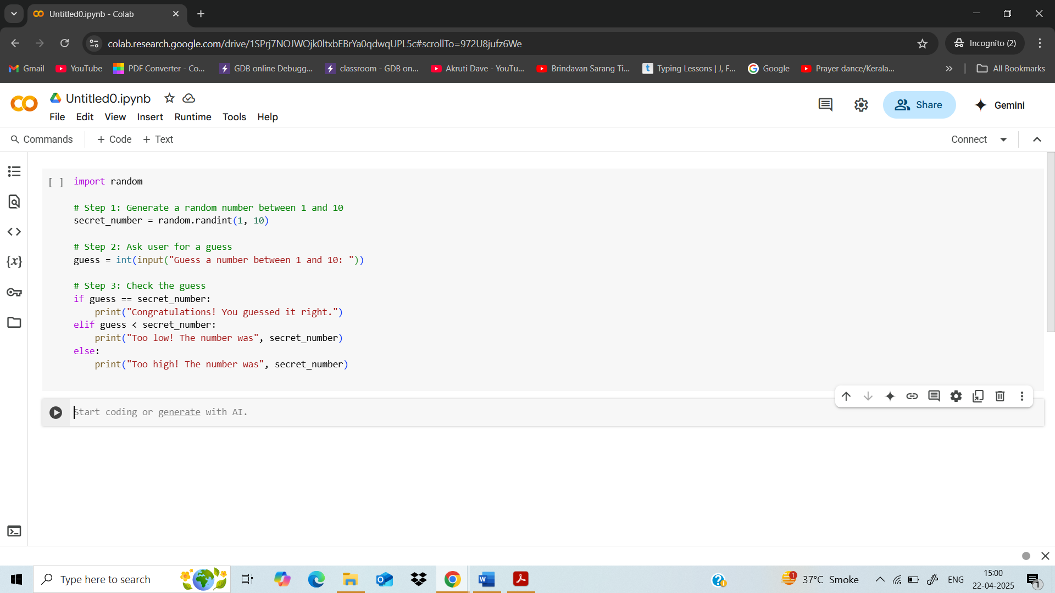

**Step 5: Run the Code**

* Hit Shift + Enter to run the cell.
* You'll get an input box below the cell where you can type a number.

